Lab Exam:

**1. Display message in lcd**

<https://www.arduino.cc/en/Tutorial/HelloWorld>

LiquidCrystal lcd(12, 11, 5, 4, 3, 2);

void setup() {

// set up the LCD's number of columns and rows:

lcd.begin(16, 2);

// Print a message to the LCD.

lcd.print("hello, world!");

}

void loop() {

// set the cursor to column 0, line 1

// (note: line 1 is the second row, since counting begins with 0):

lcd.setCursor(0, 1);

// print the number of seconds since reset:

lcd.print(millis() / 1000);

}

—————————————————————-

**2. Ultrasonic Module(Gnd, VCC, Trig, Echo)**

[**https://howtomechatronics.com/tutorials/arduino/ultrasonic-sensor-hc-sr04/**](https://howtomechatronics.com/tutorials/arduino/ultrasonic-sensor-hc-sr04/)

#include <Arduino.h>

#include <LiquidCrystal.h>

#define trigger A4

#define echo A5

LiquidCrystal lcd(12, 11, 5, 4, 3, 2);

float time = 0, distance = 0;

void setup()

{

Serial.begin(9600);

lcd.begin(16, 2);

pinMode(trigger, OUTPUT);

pinMode(echo, INPUT);

lcd.print(" Ultra sonic");

lcd.setCursor(0, 1);

lcd.print("Distance Meter");

delay(2000);

lcd.clear();

}

void loop()

{

lcd.clear();

digitalWrite(trigger, LOW);

delayMicroseconds(2);

digitalWrite(trigger, HIGH);

delayMicroseconds(10);

digitalWrite(trigger, LOW);

delayMicroseconds(2);

time = pulseIn(echo, HIGH);

distance = time * 0.034/ 2;

Serial.println(distance);

lcd.clear();

lcd.print("Distance:");

lcd.print(distance);

lcd.print("cm");

lcd.setCursor(0, 1);

lcd.print("Distance:");

lcd.print(distance / 100);

lcd.print("m");

delay(1000);

1. digitalWrite(trigPin, LOW);
2. delayMicroseconds(2);
3. // Sets the trigPin on HIGH state for 10 micro seconds
4. digitalWrite(trigPin, HIGH);
5. delayMicroseconds(10);
6. digitalWrite(trigPin, LOW);
7. // Reads the echoPin, returns the sound wave travel time in microseconds
8. duration = pulseIn(echoPin, HIGH);
9. // Calculating the distance
10. distance= duration*0.034/2;
11. // Prints the distance on the Serial Monitor
12. Serial.print("Distance: ");
13. Serial.println(distance);

}

3.Temperature Humidity Sensor:(vcc,gnd, 7)

<http://www.circuitbasics.com/how-to-set-up-the-dht11-humidity-sensor-on-an-arduino/>

#include "DHT.h"

#include <LiquidCrystal.h>

LiquidCrystal lcd(12, 11, 5, 4, 3, 2);

DHT dht;

#define DHT11_PIN 7

void setup()

{

lcd.begin(16, 2);

dht.setup(7); // data pin 7

}

void loop()

{

delay(dht.getMinimumSamplingPeriod());

float humidity = dht.getHumidity();

float temperature = dht.getTemperature();

lcd.setCursor(0, 0);

lcd.print("Temp: ");

lcd.print(temperature);

lcd.print((char)223);

lcd.print("C");

lcd.setCursor(0, 1);

lcd.print("Humidity: ");

lcd.print(humidity);

lcd.print("%");

delay(1000);

}

-----------------------------------------------------------------------------

4. Infrared Module(vcc, gnd, out)

LED (big leg at 13, small leg at gnd)

<https://etechnophiles.com/beginners-guide-to-ir-sensor-and-how-to-use-it-with-arduino/>

const int ProxSensor=2;

int inputVal = 0;

void setup()

{

pinMode(13, OUTPUT); // Pin 13 has an LED connected on most Arduino boards:

pinMode(ProxSensor,INPUT); //Pin 2 is connected to the output of proximity sensor

Serial.begin(9600);

}

void loop()

{

if(digitalRead(ProxSensor)==HIGH) //Check the sensor output

{

digitalWrite(13, HIGH); // set the LED on

}

else

{

digitalWrite(13, LOW); // set the LED off

}

inputVal = digitalRead(ProxSensor);

Serial.println(inputVal);

delay(1000); // wait for a second

}

--------------------------------------------------------------------------------

5. LDR Sensor(5v,ipput-A0)

<https://circuitdigest.com/microcontroller-projects/arduino-light-sensor-using-ldr>

// include the library code:

#include <LiquidCrystal.h>

LiquidCrystal lcd(12, 11, 5, 4, 3, 2);

const int ledPin = 13;

const int ldrPin = A0;

void setup() { //initialise for at least 2s

Serial.begin(9600);

lcd.begin(16, 2);

lcd.print("INITIALISING");

pinMode(ledPin, OUTPUT);

pinMode(ldrPin, INPUT);

}

void loop()

{

int sensorValue = analogRead(A0);

lcd.clear();

lcd.setCursor(0, 0);

lcd.print("LIGHT LEVEL:");

lcd.print(sensorValue);

lcd.setCursor(0, 1);

if (sensorValue <= 200) {

digitalWrite(ledPin, HIGH);

Serial.print("Its DARK, Turn on the LED : ");

Serial.println(sensorValue);

} else {

digitalWrite(ledPin, LOW);

Serial.print("Its BRIGHT, Turn off the LED : ");

Serial.println(sensorValue);

}

}

-----------------------------------------

6.Keypad Module(right to left --- 2 to 9)

<https://create.arduino.cc/projecthub/techmirtz/using-4x4-keypad-with-arduino-2d22e9>

#include <Keypad.h>

#include <LiquidCrystal.h>

LiquidCrystal lcd(13, 12, 11, 10, 1, 0);

const byte ROWS = 4;

const byte COLS = 4;

char hexaKeys[ROWS][COLS] = {

{'1', '2', '3', 'A'},

{'4', '5', '6', 'B'},

{'7', '8', '9', 'C'},

{'*', '0', '#', 'D'}

};

byte rowPins[ROWS] = {9, 8, 7, 6};

byte colPins[COLS] = {5, 4, 3, 2};

Keypad customKeypad = Keypad(makeKeymap(hexaKeys), rowPins, colPins, ROWS, COLS);

void setup(){

Serial.begin(9600);

lcd.begin(16, 2);

lcd.print("KEYPAD LCD TEST");

}

void loop(){

char customKey = customKeypad.getKey();

lcd.setCursor(0, 1);

if (customKey){

//lcd.print("KEY= ");

lcd.setCursor(9, 1);

//lcd.print(customKey);

Serial.println(customKey);

}

}

-------------------------------------

7. Seven Segment Display

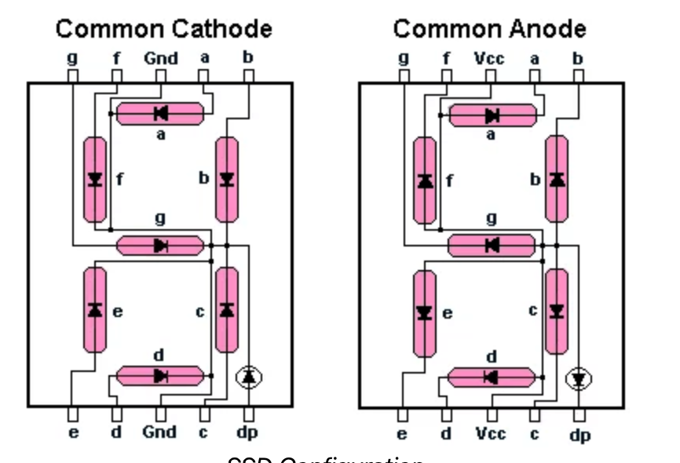

<https://www.allaboutcircuits.com/projects/interface-a-seven-segment-display-to-an-arduino/>

|  |  |  |
| --- | --- | --- |
| **Seven segment pins** | **Arduino pins** | **Wire Color** |
| 1(e) | 6 | orange |
| 2(d) | 5 | white |
| 3,8(COM) | GND | n/a |
| c | 4 | yellow |
| 5(dp) | - |  |
| 6(b) | 3 | red |
| 7(a) | 2 | blue |
| 9(f) | 7 | cyan |
| 10(g) | 8 | green |

**For printing numbers 0-9**

int num_array[10][7] = { { 1,1,1,1,1,1,0 }, // 0

{ 0,1,1,0,0,0,0 }, // 1

{ 1,1,0,1,1,0,1 }, // 2

{ 1,1,1,1,0,0,1 }, // 3

{ 0,1,1,0,0,1,1 }, // 4

{ 1,0,1,1,0,1,1 }, // 5

{ 1,0,1,1,1,1,1 }, // 6

{ 1,1,1,0,0,0,0 }, // 7

{ 1,1,1,1,1,1,1 }, // 8

{ 1,1,1,0,0,1,1 }}; // 9

//function header

void Num_Write(int);

void setup()

{

// set pin modes

pinMode(2, OUTPUT);

pinMode(3, OUTPUT);

pinMode(4, OUTPUT);

pinMode(5, OUTPUT);

pinMode(6, OUTPUT);

pinMode(7, OUTPUT);

pinMode(8, OUTPUT);

}

void loop()

{

//counter loop

for (int counter = 10; counter > 0; --counter)

{

delay(1000);

Num_Write(counter-1);

}

delay(3000);

}

// this functions writes values to the sev seg pins

void Num_Write(int number)

{

int pin= 2;

for (int j=0; j < 7; j++) {

digitalWrite(pin, num_array[number][j]);

pin++;

}

}

-----------------------------

8. Servo Motor (9, vcc,gnd----- in the same order)

(180 degree rotate)

<https://www.allaboutcircuits.com/projects/servo-motor-control-with-an-arduino/>

#include <Servo.h> //Servo library

Servo servo_test; //initialize a servo object for the connected servo

int angle = 0;

void setup()

{

servo_test.attach(9); // attach the signal pin of servo to pin9 of arduino

}

void loop()

{

for(angle = 0; angle < 180; angle += 1) // command to move from 0 degrees to 180 degrees

{

servo_test.write(angle); //command to rotate the servo to the specified angle

delay(15);

}

delay(1000);

for(angle = 180; angle>=1; angle-=5) // command to move from 180 degrees to 0 degrees

{

servo_test.write(angle); //command to rotate the servo to the specified angle

delay(5);

}

delay(1000);

}

-------------------------------------------------

9. Stepper Motor

Drivermodule

In1-8

In2-9

In3-10

In4-11

Vcc,gnd

<https://circuitdigest.com/microcontroller-projects/arduino-stepper-motor-control-tutorial>

#include <Stepper.h> // Include the header file

// change this to the number of steps on your motor

#define STEPS 32

// create an instance of the stepper class using the steps and pins

Stepper stepper(STEPS, 8, 10, 9, 11);

int val = 0;

void setup() {

Serial.begin(9600);

stepper.setSpeed(200);

}

void loop() {

if (Serial.available()>0)

{

val = Serial.parseInt();

stepper.step(val);

Serial.println(val); //for debugging

}

}